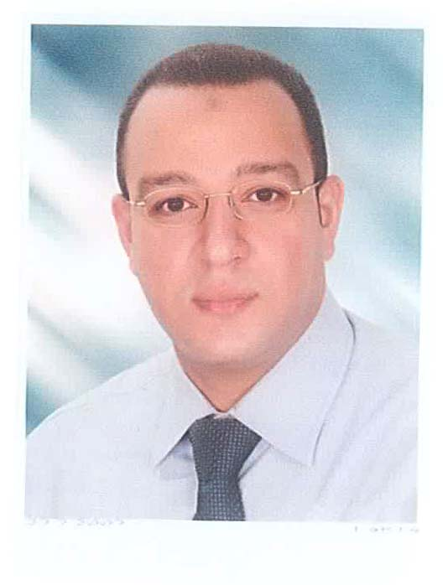
Curriculum Vitae
Name: Mohamed Kotb Mohamed Abdel-hafez
Position: Lecturer Assistant at department of chemistry, Faculty of science,
Assiut University, Assiut, Egypt

Date & Place of birth: Sep. 22, 1977- El-Minia, Egypt
Gender: Male
Phone: 002-088-2363960 (Home) - 002-088-2412033 (Work)
002-01227432088 (Mobile)
Fax: 002-088-2342708
E-mail: kotb3hf@yahoo.com

Academic Qualifications
Degree | Date | Institution | Field
B. Sc. | 09/1995 - 06/2000 | Assiut University | Chemistry
M.Sc. | 11/2003 – 07/2009 | Assiut University | Chemistry

The Title of my M.Sc Thesis is:
"ELECTROCHEMICAL STUDIES ON SOME FLAVONOID COMPOUNDS AT CHARGED INTERFACES"
Fields of interest:

1) Analytical and Electroanalytical Chemistry
2) Bioelectrochemistry
3) Materials Science (Nanotechnology)
4) Drug-DNA Interactions

Work and teaching experiences:

- 14 years teaching practical analytical, inorganic and physical chemistry courses
in chemistry department, faculty of science, Assiut university, Assiut, Egypt.

- Experienced with the operation and applications of various analytical techniques and instruments such as Voltammetry (Cyclic Voltammetry, Square-wave Voltammetry, Diffrential Pulse Voltammetry), Stripping techniques (DPSV, DCSV) and Spectrophotometry (UV-vis Spectrophotometry).

Puplications:
- Y. M. Temerk, M. S. Ibrahim, M. Kotb, Voltammetric and Spectroscopic Studies on Binding of Antitumor Morin, Morin-Cu Complex and Morin-β-Cyclodextrin with DNA. Spectrochimica Acta Part A 71 (2009) 1830–1836
- Y. M. Temerk, M. S. Ibrahim, M. Kotb, Square-Wave Cathodic Adsorptive Stripping Voltammetric Determination of 3-Hydroxylavone, Morin and Hesperidin in Bulk Form and Biological Fluids in Absence and Presence of Cu(II). J. Braz. Chem. Soc., Vol. 22, No. 11 (2011) 2056-2064.
- Y. M. Temerk, M. S. Ibrahim, W. Schuhmann, M. Kotb, Interaction of antitumor flavonoids with dsDNA in the absence and presence of Cu(II). Anal Bioanal Chem 405 (2013) 3839–3846
- Y. M. Temerk, M. S. Ibrahim, W. Schuhmann, M. Kotb, Renewable Pencil Electrodes for Highly Sensitive Anodic Stripping Voltammetric Determination of 3-Hydroxyflavone and Morin in Bulk Form and in Biological Fluids. Electroanalysis 25, No. 6 (2013) 1381 – 1387.
- M. S. Ibrahim, Y. M. Temerk, H. Ibrahim, M. Kotb, Indium oxide nanoparticles modiﬁed carbon paste electrode for sensitive voltammetric determination of aromatase inhibitor formestane. Sensors and Actuators B 209 (2015) 630–638.
- Y. M. Temerk, M. S. Ibrahim, H. Ibrahim, M. Kotb, Interactions of an anticancer drug Formestane with single and double stranded DNA at physiological conditions. J. Photochem. Photobiol. B. 149 (2015) 27-36.

Other skills:
- Computer
- English (very good).

